The Importance of Visuals in Interior Design Projects

In the world of interior design, visuals are more than just pretty pictures—they are essential communication tools that bridge the gap between concept and reality. Whether presenting ideas to clients, coordinating with contractors, or refining creative concepts, visuals are at the heart of every successful interior design project.

# Why Visuals Matter

Interior design is inherently visual. Clients often struggle to understand abstract ideas or interpret written descriptions. Visuals provide a tangible, clear representation of spatial arrangements, materials, lighting, and colour palettes. They help stakeholders see the potential of a space long before any physical work begins.

## Key Benefits:

Effective Communication: Visuals convey ideas quickly and clearly, reducing misunderstandings.

Enhanced Client Buy-In: Clients are more likely to feel confident and excited when they can see the vision.

Design Accuracy: Visual tools help identify potential issues in layout, scale, or aesthetics before construction starts.

Collaboration: Visuals streamline communication between designers, architects, contractors, and vendors.

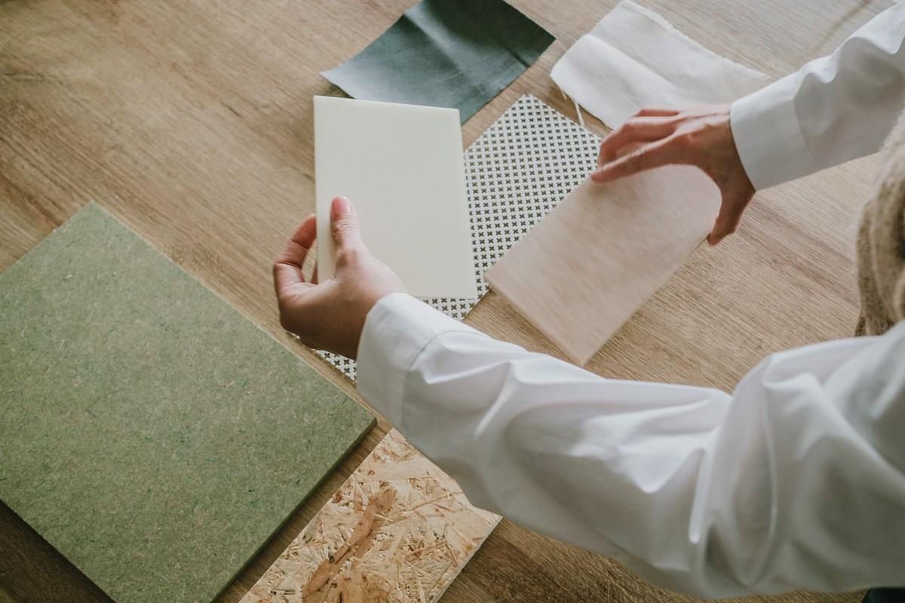

Fig 1. Canva (nd), [Interior Designer selecting materials](https://www.canva.com/photos/MAFT7zU4Mm8/)

# Types of Visuals in Interior Design

Different phases of a project require different types of visuals. Here are the most commonly used ones:

## Concept Boards & Sample Boards

A collage of colours, textures, materials, and inspiration images. Sets the tone and atmosphere of the design.

## Preliminary Sketches

Freehand drawings that capture the early ideas of a space. Help visualise spatial layout and key elements.

## Floor Plans

2D Top-down drawings that show room layout, furniture arrangement, and spatial flow. 

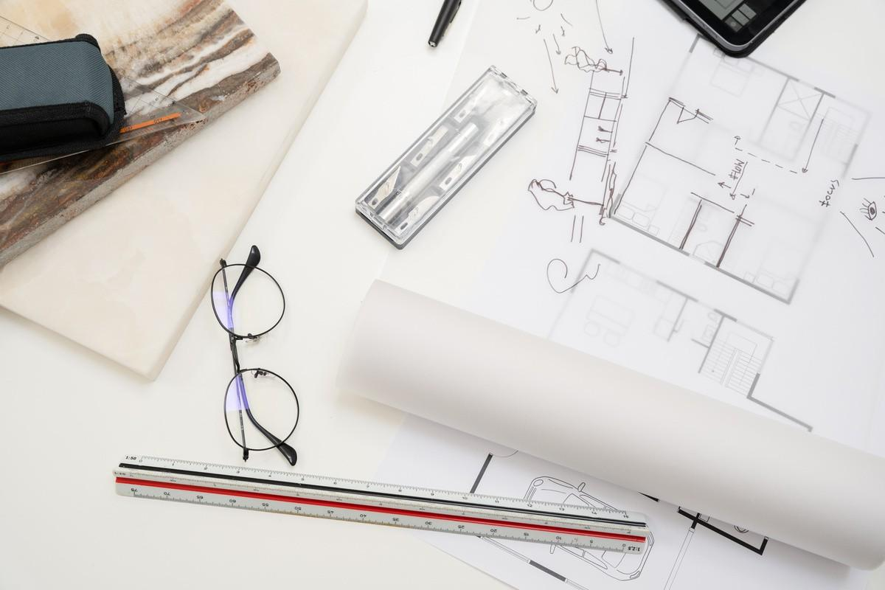

Fig 2. Canva (nd), Sketches [and Design tools](https://www.canva.com/photos/MAFifXxr6xg/)

## Elevations and Sections

Flat views showing vertical surfaces (walls) or cut-throughs of a space. Useful for detailing cabinetry, wall treatments, or custom installations.

## 3D Renderings

Photorealistic images created digitally to showcase how a space will look. Often used in client presentations.

## Virtual Walkthroughs / 3D Models

## Immersive, interactive experiences that allow clients to explore a space. Increasingly used thanks to advancements in digital design tools.

# Manual Vs Digital Visuals

Designers can create visuals manually (by hand) or digitally (using software). Both methods have their place, and each comes with pros and cons. Let’s have a look a these in detail:

## Manual Drawings

Pros:

Expressive and Personal: Sketches often convey creativity and emotion. Quick for Conceptual Work: Great for brainstorming and rough ideas.

Tactile Experience: Drawing by hand can enhance the creative process.

Cons:

Time-Consuming for Final Work: Difficult to make changes or scale details.

Limited Accuracy: Not always precise, especially for measurements or technical specs. Harder to Share and Edit: Not as convenient for collaborative projects.

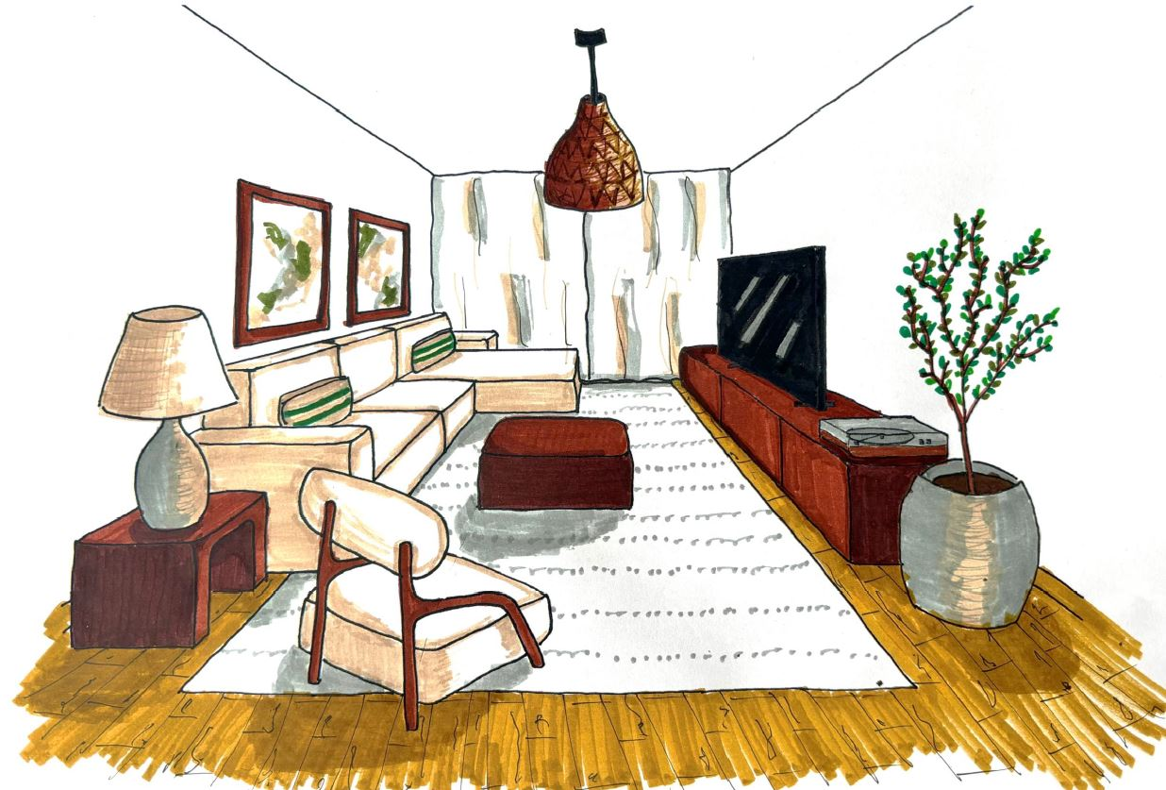

Fig 3. Living room manual drawing

## Digital Drawings

Pros:

High Accuracy: Ideal for detailed floor plans and technical drawings.

Easily Editable: Changes can be made quickly without starting from scratch. Professional Presentation: Clean, polished visuals enhance client perception. Integration with 3D Tools: Can be used to generate renderings and walkthroughs.

Cons:

Steeper Learning Curve: Requires proficiency in design software (e.g., AutoCAD, SketchUp, Revit).

Less Spontaneous: Can feel rigid during early creative exploration.

Equipment Dependency: Requires a computer or tablet and often expensive software.

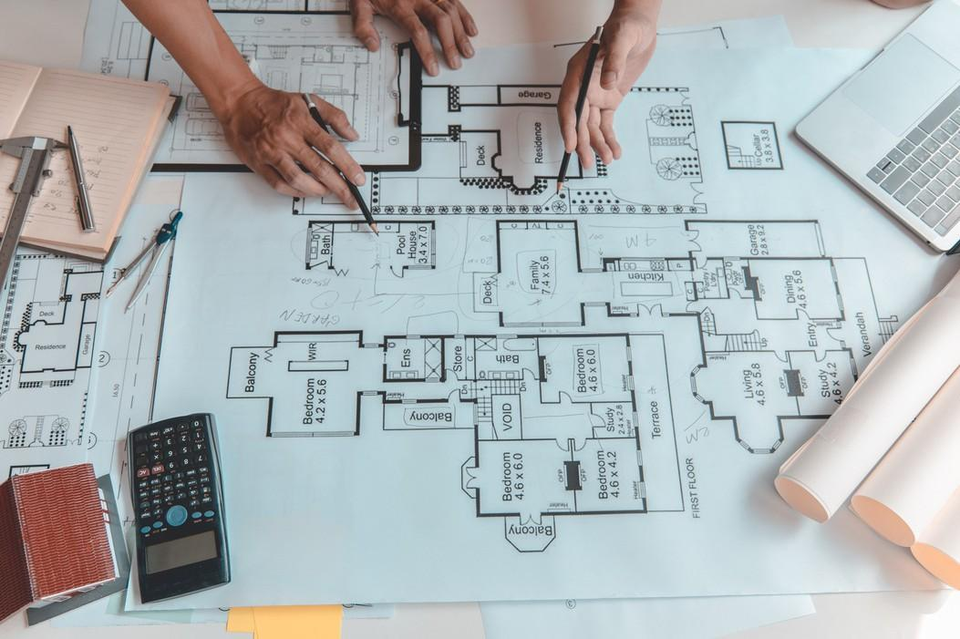

Fig 4. Canva (nd), Digital f[loor plan](https://www.canva.com/photos/MAEmOOHeVCA/) drawing

The best designers know how to blend both manual and digital techniques. Early sketches may be done by hand to quickly capture ideas, while final presentations are polished using digital tools. Learning when and how to use each method is a key skill in interior design.

Here are some tips for you to start implementing visuals into your practice as an Interior Designer:

Start with sketches to explore ideas freely.

Learn essential software tools for professional output.

Don’t underestimate the value of mood boards—they set the emotional tone. Practice presenting visuals as part of your design narrative.

Visuals are the lifeblood of interior design. From rough sketches to immersive 3D walkthroughs, they allow designers to communicate, refine, and sell their ideas with clarity and confidence.

Understanding how to use both manual and digital visuals effectively can elevate a project—and a designer’s career—from good to extraordinary.

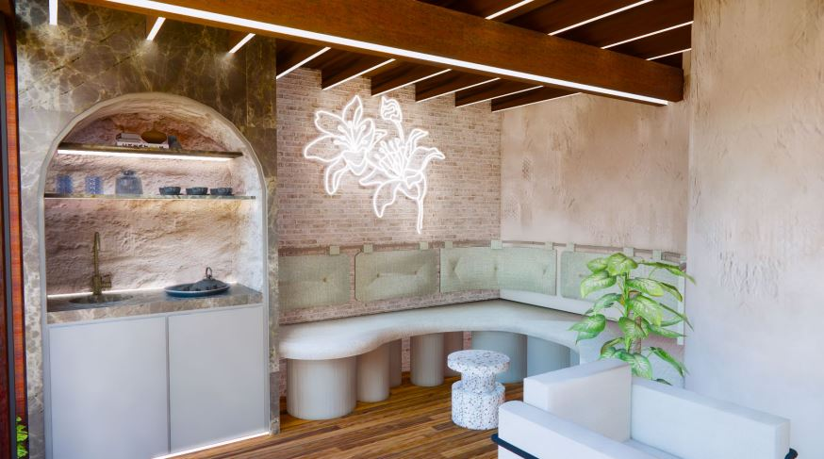

Fig 5. 3D image produced for a Meditation Centre